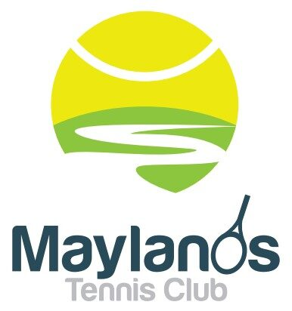
Maylands Tennis Club (Inc)

CLARKSON RESERVE, MAYLANDS, WA 6051
P.O. BOX 38 MAYLANDS WA 6931
email: maylandstennis@yahoo.com.au www.maylandstc.com
ABN: 90 668 559 941

Maylands Tennis Club Feedback Form
We appreciate your opinions and take each comment seriously.
Name:
Email:
Contact Number:
Member status:

Thank you for taking the time to complete our short survey - all information will be valuable in helping us to create the best possible tennis club for everyone.

